Goring Heath and Whitchurch
Spring Show

Saturday 7 April 2018
2.30 pm to 4.00 pm
Goring Heath Parish Hall

OPEN TO ALL RESIDENTS OF GORING HEATH AND WHITCHURCH
Entry Forms should be given to a Committee member from Wednesday 4 April and no later than 4.30pm on Friday 6 April 2018.

PROGRAMME
Exhibitors’ staging | 9.00 am – 10.15 am
Judging | 10.30 am - 12.30 pm
Open for public viewing | from 2.30 pm
Presentation of Trophies | 3.30 pm
Raffle | 3.45 pm approx

* Refreshments available all afternoon *
Entry forms and schedules can be downloaded from
www.whitchurchonthames.com/diary.php
and
www.goringheath.com
Trophies and Prizes
- The Betty Hayter Memorial Cup will be awarded to the Competitor with the most points in Section A (Flowers).
- A Floral Arrangement Trophy will be awarded to the Competitor with the most points in Section C (Flower Arranging).
- A Handicraft Trophy will be awarded to the Competitor with the most points in the Handicraft Classes.
- An Art Trophy will be awarded to the Competitor with the most points in the Art Classes
- An Arts and Crafts Trophy will be awarded to the Competitor with the most points in Section D for Art and Handicraft.
- An Egg Cup will be awarded to the competitor with the most points gained in Section F.
- Baking and Preserves Cup will be awarded to the Competitor with the most points in Section G.
- The Photography Cup will be awarded to the Competitor with the most points in Section H.
- The Douglas Allardyce Memorial Rose Bowl will be awarded to the most outstanding exhibit in the Vegetable, Fruit and Flower Sections A and B.
- A Cup and rosettes will be awarded to the winner/s of Section E (Children up to 12 years of age).
- The Whitchurch Hill Trophy will be awarded to the Competitor with the most points overall.
SECTION A
FLOWERS
Judge – David Woodage
NOTE: The distinguishing characteristic of a trumpet daffodil is one flower on a stem; its trumpet or corona is as long or longer than the perianth segments (outer petals). Blooms with shorter trumpets should be exhibited in the narcissus classes. ‘Mixed’ means more than one variety.
- Specimen bloom of trumpet daffodil, any colour
- Specimen bloom or stem of narcissus, any colour
- Vase of trumpet daffodils, three varieties, one bloom of each
- Vase of narcissi, three varieties, one bloom of each
- Vase of narcissi, three stems, with more than one bloom of each
- Vase of miniature daffodils or narcissi, three stems of one variety
- One specimen bloom of tulip
- Vase of tulips, three blooms, mixed or single variety
- Vase of muscari (grape hyacinth), six stems
- Vase of polyanthus, five stems
- Vase of primroses, five stems
- Vase of hellebores, colour variation allowed, five stems
- Vase of spring flowers, outdoor grown, one kind, colour variation allowed, five stems
- Vase of mixed spring flowers, with own foliage, excluding shrubs, five stems
- Vase of flowers from trees or shrubs, mixed, five stems
- An alpine plant, in the exhibitor’s possession for at least six months, maximum pot size 7ins/18cms
- Pot or bowl of any flowering plant(s), including bulbs, corms or tubers, maximum pot size 10ins/24cms
- Pot or bowl of succulent or succulents, maximum pot size 7ins/18cms
- Pot or bowl of a cactus or cacti, maximum pot size 7ins/18cms

SECTION B
FRUIT AND VEGETABLES
Judge – David Woodage
- Four sticks of rhubarb to be shown with leaves trimmed to 3ins/7.5cms and the bottom white heel left on
- Any variety of vegetable, other than rhubarb, number optional

SECTION C
FLOWER ARRANGING
Judges – Sally and Lorna Woolhouse
To be viewed from the front, dimensions not to exceed 16ins/40cms.
- An Easter celebration
- A table centrepiece
- An arrangement in a wine glass

SECTION D
ARTS AND CRAFTS
Judges – Sally and Lorna Woolhouse
HANDICRAFT
- An article of tapestry
- A decorated box for a gift
- A knitted or crocheted hat

ART
No item larger than A3
- A river scene
- A three coloured pattern
- Flowers in spring
Competitors are responsible for supplying their own equipment to display their entries, unless otherwise stated

SECTION E
CHILDREN (UP TO 12 YEARS)
Judges – Sally and Lorna Woolhouse
Children’s ages must be written on exhibitors’ cards
Judges – Sally and Lorna Woolhouse
- Four chocolate rice crispy cakes
- An animal picture in any medium
- Five primroses in an appropriate container
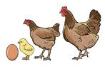
SECTION F
EGGS
Judge – Caroline Hadley
- Three identical hens’ eggs
- Three bantam eggs, same colour
- Three waterfowl eggs
- Six eggs, attractively displayed

SECTION G
BAKING AND PRESERVES
Judge – Regula Adams
Jars must be plain and have fresh labels as required. The preserves must be covered with a wax circle and a cellophane top. Jars to be filled within 6mm of the top.
- A jar of marmalade
- A lemon drizzle cake (recipe supplied)
- A mushroom quiche
- Four butterfly cakes

Lemon Drizzle Cake
Ingredients
140g butter at room temperature
140g caster sugar
2 large eggs
Grated zest of 1 unwaxed lemon
140g of self-raising flour

Lemon topping
4 tablespoons caster sugar
Freshly squeezed juice of 1 lemon

A 20cm loose based square cake tin OR a 23cm loose based round cake tin, lined with greaseproof paper.

Method
Preheat the oven to 180 degrees C (350 degrees F).
Beat together the butter and sugar in a bowl until pale and creamy.
Beat in the eggs one at a time, then stir in the lemon zest.
Sift the flower into the mixture and fold in until well mixed.
Tip the mixture into the prepared cake tin and spread out evenly.
Bake in the preheated oven for about 20 minutes until risen and golden and a skewer inserted in the centre comes out clean.
Transfer the cake tin to a wire rack and prick the top of the cake all over using the skewer. Dust with 1 tablespoon of the sugar for the topping.
Quickly combine the remaining sugar and lemon juice in a small bowl and immediately pour over the top of the cake. Let cool in the tin, then carefully unmould to serve.

SECTION H
PHOTOGRAPHY
Judge – Jim Donahue
Entries may be in black & white or
colour. Maximum size A4 (29.7cm x
21cm / 11.7” x 8.3” including mount. You may only enter one photograph per class.
- Building/s
- A Winter scene
- Sheer Joy
AUTUMN SHOW
Saturday 8 September 2018
Photography Section Classes
A Party
Wildlife in the Garden
A Holiday Photograph

Liz Gibson  Nurses Cottage  Bridle Road  Whitchurch Hill  0118 984 2012  liznursescott@talktalk.net | Sue Sexon  3 Rivacres  Whitchurch Hill  0118 984 4236  suesexon@yahoo.co.uk | Sally Trinder  The Gables  Eastfield Lane  Whitchurch-on-Thames  0118 984 2610  sallytrinder@talktalk.net

Rules of Entry
1. Entry Forms 30p per entry must reach the organisers, as detailed in this schedule. Late entries (50p) are at the discretion of the Committee.
2. Entry is open to residents of Whitchurch and Goring Heath, plus children attending schools and allotment holders within the two Parishes.
3. An individual may only make one entry per class.
4. Two or more persons may not exhibit separately in the same class in the Flower and Fruit and Vegetable Sections from the same garden or allotment.
5. Exhibitors in all Sections are expected to be local amateurs.
6. Exhibits in the Flower and Fruit and Vegetable Sections must have been grown by the exhibitor in his/her own garden or allotment.
7. Exhibits must be staged on the day of the Show between the times stated in this schedule. No exhibit may be removed before the end of the Show.
8. The Committee will not be held responsible for any loss or damage, although every care will be taken to avoid it.
9. Accessories in the Flower Arranging Class must not predominate over plant material.
10. Exhibits in the Baking and Preserves Section must be homemade.
11. The decisions of the judges are final. If there are three or fewer entries in one class, prizes may be awarded or not, at the discretion of the judges.
12. All items should be exactly as described in the schedule or they may be disqualified.
13. Trophies may be held until the following Show. Winners are asked to return them to the organiser one month before the following show.
14. Children’s ages must be included on the entry form.

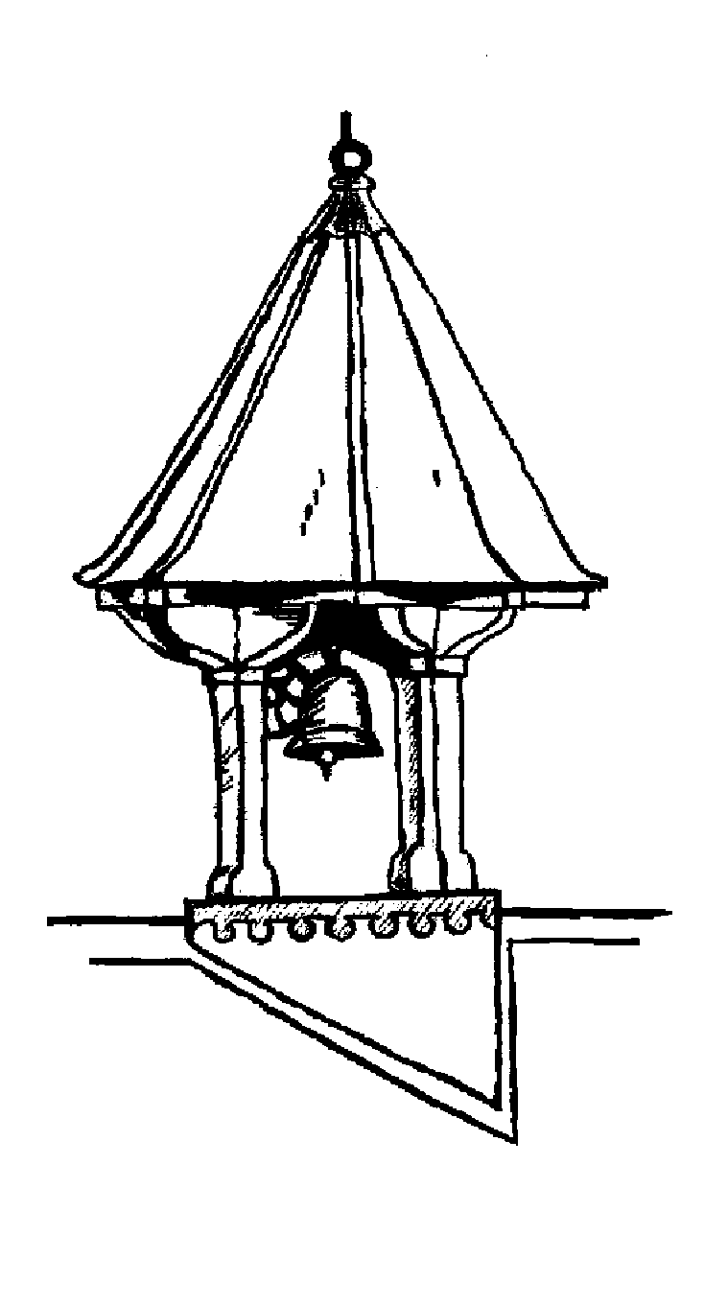
Goring Heath Parish Charity
SPRING 2018 SHOW
ENTRY FORM
Please use the form below for your entries.
Number of entries: ___ I enclose fees (30p per entry): ___
Name : _________________ Tel No : ________________
Address : ______________________________________
___________________________ Age of child : ________
All entry forms should be given to a member of the committee from Wednesday 4 April and no later than 4.30pm on Friday 6 April 2018. Late entries only at the discretion of the committee. See overleaf for contact details.
Please circle below the number of each class you are entering.

Section | Class
A | 1 | 2 | 3 | 4 | 5 | 6 | 7 | 8 | 9 | 10 | 11 | 12 | 13 | 14 | 15 | 16
A | 17 | 18 | 19
B | 20 | 21
C | 22 | 23 | 24
D | 25 | 26 | 27 | 28 | 29 | 30
E | 31 | 32 | 33
F | 34 | 35 | 36 | 37
G | 38 | 39 | 40 | 41
H | 42 | 43 | 44

Please make sure that you read the schedule carefully. For copies of schedule or entry form please go to http://www.whitchurchonthames.com/diary.php or www.goringheath.com

