Goring Heath Parish Council
PRECEPT FOR 2024125
To: Soutl Oxfordshire District Council
(being tie Coundl of the district in which tie a ve named Town/Parish is situated)
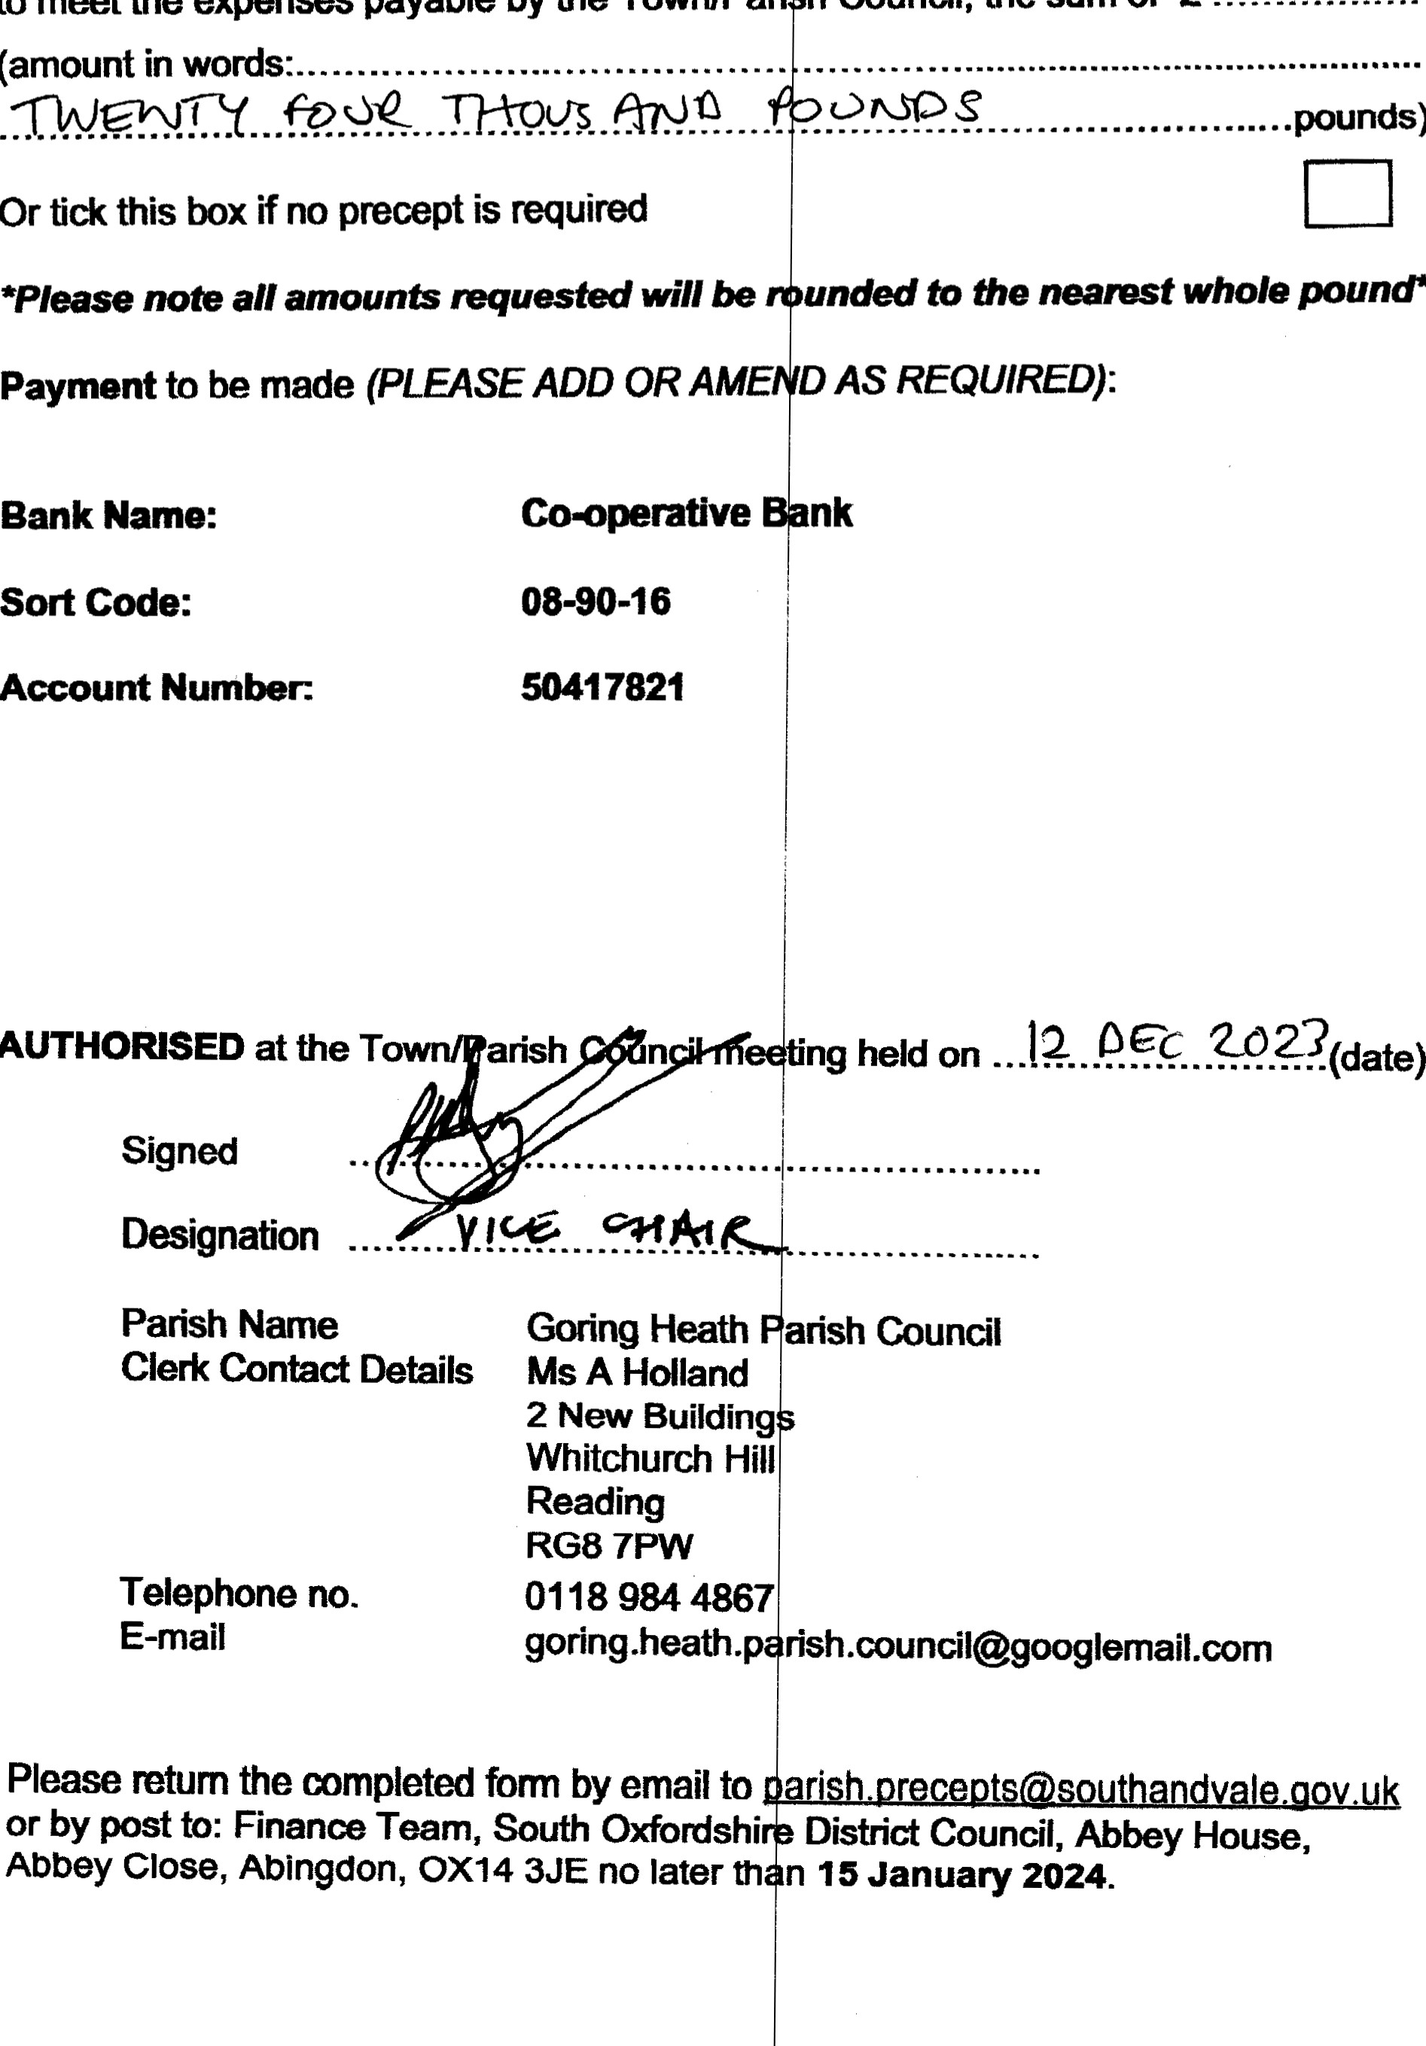
You are herebv directed to pay Goring Heath P rish Council,
pounds)
pound*
AUTHORISED
to
meet
the
expenses
payable
by
the
Town/Pari
h
Council,
the
sum
of
E
Parish Name Goring Heath
Clerk Contact Details Ms A Holland 2 New Building
Whitchurch Hill
Reading

RG8 7PW
Telephone no. 0118 984 4867 E-mail goring.heath.p
Please retum the mmpleted form by email to or by post to: Finance Team, South Oxfordshi Abbey Close, Abingdon, OX14 3JE no later th

