Goring Heath and Whitchurch
Autumn Show
Saturday 2 September 2017
2.30 pm to 4.00 pm
Goring Heath Parish Hall

OPEN TO ALL RESIDENTS OF GORING HEATH AND WHITCHURCH
Entry Forms should be given to a Committee member from Wednesday 30 August and no later than 4.30pm on Friday 1 September 2017.

PROGRAMME
Exhibitors’ staging | 9.00 am – 10.15 am
Judging | 10.30 am - 12.30 pm
Open for public viewing | from 2.30 pm
Presentation of Trophies | 3.30 pm
Raffle | 3.45 pm approx

* Refreshments available all afternoon *
Entry forms and schedules can be downloaded from
www.whitchurchonthames.com/diary.php
and
www.goringheath.com

Trophies and Prizes
- The Allotment Cup will be awarded to the Competitor with the most points in Section A (Vegetables and Fruit).
- The Betty Hayter Memorial Cup will be awarded to the Competitor with the most points in Section B (Flowers).
- A Floral Arrangement Trophy will be awarded to the Competitor with the most points in Section D (Flower Arranging).
- A Handicraft Trophy will be awarded to the Competitor with the most points in the Handicraft Classes.
- An Art Trophy will be awarded to the Competitor with the most points in the Art Classes
- An Arts and Crafts Trophy will be awarded to the Competitor with the most points in Section E for Art and Handicraft.
- A Cup and rosettes will be awarded to the winner/s of Section F (Children up to 12 years of age).
- Baking and Preserves Cup will be awarded to the Competitor with the most points in Section G.
- The Photography Cup will be awarded to the Competitor with the most points in Section H.
- The Douglas Allardyce Memorial Rose Bowl will be awarded to the most outstanding exhibit in the Vegetable, Fruit and Flower Sections A and B.
- The Whitchurch Hill Trophy will be awarded to the Competitor with the most points overall.
SECTION A
FRUIT AND VEGETABLES
Judge – Rodney Davis
See Helpful Hints
- Three onions, over 250g, any one variety
- Three onions, 250g or under, any one variety
- Seven shallots, any one variety
- Five potatoes, any one white variety
- Five potatoes, any one coloured variety
- Three carrots, one variety
- Five runner beans, with stalks, any one variety
- The longest runner bean, with stalk
- Five French beans, with stalk, any one variety
- Five tomatoes, one variety, excluding cherry type
- A ripening truss of cherry tomatoes
- Three tomatoes, mixed variety
- Three beetroot, one variety
- The heaviest marrow
- Three courgettes, one variety, max length 150mm / 6ins
- Three peppers or chillies, hot or sweet, any one variety
- A basket or other container of four different vegetables, as gathered
- Three dessert apples, one variety
- Three culinary apples, one variety
- Five plums, one variety
- Any other fruit, not included elsewhere, number optional
- Twelve blackberries, with stalks
- Dish of six of any one variety of soft fruit, with stalks
- Any amusingly shaped vegetable or fruit
- Any other vegetable, not included elsewhere, number optional
- Vase of mixed herbs ~ use of the vases provided is obligatory
SECTION B
FLOWERs
Judges – Rodney Davis
Please note that exhibitors should use the vases provided.
- A vase of three hybrid tea rose blooms, mixed or of one variety
- A vase of three floribunda sprays, mixed or of one variety
- One hybrid tea rose bloom
- A vase of three mixed specimen chrysanthemum blooms
- A vase of three stems of spray chrysanthemums
- A vase of three pelargonium heads
- A vase of three dahlia blooms, one variety
- A vase of three mixed dahlia blooms
- One specimen dahlia bloom
- A flower, single stem (other than dahlia or rose) in a decorative vase of your own choice, both to be judged
- A vase of four stems of different herbaceous perennials
- A vase of four different annual blooms
- A pot or bowl of any flowering plant, in the exhibitor’s possession for at least 3 months – maximum pot size 24cms / 10ins diameter
- Fuchsia, one bush variety in a pot (max 20cms / 8ins diameter)
- A container, suitably planted, up to 30cms / 12ins
- An unusual container, appropriately planted
SECTION C
BAKING AND PRESERVES
Judge – Margaret King
Preserves must be presented in plain jars (filled to within 6mm of top), covered with either a plain sealed metal lid or a plastic/paper cover and labelled.
- A jar of soft or stoned fruit jam
- A Chocolate Victoria Sandwich (recipe supplied)
- Four cheese scones
- Four jam tarts
Chocolate Victoria Sandwich
Ingredients for cake
2 tablespoons cocoa
3 tablespoons boiling water
225g (8oz) softened butter
225g (8oz) caster sugar
4 large eggs
225g (8oz) self-raising flour
2 level teaspoons baking powder

Ingredients for the filling and topping
50g (2oz) softened butter
175g (6oz) sifted icing sugar
1 tablespoon milk
Coarsely grated chocolate to decorate

Method for cake
Preheat the oven to 180°C/Fan 160°C. Gas 4. Grease two 20 cm (8in) sandwich tins then line the base of each tin with baking parchment.
Blend the cocoa and water in a mixing bowl then leave to cool slightly. Measure all the remaining ingredients into the bowl and beat until thoroughly blended. Divide the mixture evenly between the tins and level out.
Bake in the preheated oven for about 25 minutes or until well risen and the tops of the cakes spring back when lightly pressed with a finger. Leave to cool in the tins for a few minutes then turn out, peel off the parchment and finish cooling on a wire rack.
To make the butter cream filling and topping, blend together the butter, icing sugar and milk until smooth. When the cake is completely cold, use half the butter cream to sandwich the cakes together, then spread the remaining butter cream on top and decorate with the grated chocolate.
Method for the filling and topping
Blend together the butter, icing sugar and milk until smooth. When the cake is completely cold, use half the butter cream to sandwich the cakes together, then spread the remaining butter cream on top and decorate with the grated chocolate.
SECTION D
Flower Arranging
Judges – Sally and Lorna Woolhouse
To be viewed from the front, dimensions not to exceed 16ins/40cms. Bought flowers may be used
- An arrangement in a jug
- Five Flowers and Foliage
- A posy
SECTION E
ARTS AND CRAFTS
Judges – Sally and Lorna Woolhouse
HANDICRAFT
- An item from something recycled
- A knitted article
- An item of needlework
ART
No item larger than A3
- A Portrait
- A Scenic View
- A Vase of Flowers
Competitors are responsible for supplying their own equipment to display their entries, unless otherwise stated

SECTION F
CHILDREN (UP TO 12 YEARS)
Judges – Sally and Lorna Woolhouse
Children’s ages must be written on exhibitors’ cards
- A Construction in ‘Lego’
- Four small iced cakes
- A painting or drawing of ‘My House’
SECTION G
PHOTOGRAPHY
Judge – Jim Donahue
Entries may be in black & white or
colour. Maximum size A4 (29.7cm x 21cm / 11.7” x 8.3” excluding mount. You may only enter one photograph per class.
- Someone and their Pet
- Something White
- A Birthday
SPRING SHOW
Saturday 7 April 2018
Photography Section Classes
Building/s
A Winter Scene
Sheer Joy

Liz Gibson  Nurses Cottage  Bridle Road  Whitchurch Hill  0118 984 2012  liznursescott@talktalk.net | Sue Sexon  3 Rivacres  Whitchurch Hill  0118 984 4236  suesexon@yahoo.co.uk | Sally Trinder  The Gables  Eastfield Lane  Whitchurch-on-Thames  0118 984 2610  sallytrinder@talktalk.net

HELPFUL HINTS
- Have you read your schedule carefully?
- Vegetables should be as even in size, as unblemished and as clean as possible.
- Basket, trug or container of vegetables as gathered. Vegetables to be shown as if freshly dug from the ground. Vegetables should not be washed, trimmed or prepared in any other way.
- Potatoes ~ to be gently washed and shown on plates.
- Tomatoes ~ to be shown with calyx on.
- Carrots ~ to be shown with leaves trimmed to 75mm / 3ins and neatly tied. Can be washed.
- Onions ~ to be shown with tops bent and tied & roots trimmed.
- Runner Beans ~ to be shown with stalks on.
- French Beans ~ as above.
- Beetroot ~ to be shown with leaves trimmed to 75mm / 3ins and neatly tied. Can be washed.
- Courgettes ~ to be shown with or without flowers on.
- Rhubarb ~ to be shown with leaves trimmed to 75mm / 3ins and the bottom white “heel” left on.
- Apples ~ to be shown with stalks on and variety named.
- Strawberries, Blackberries, Raspberries, Loganberries ~ to be shown with stalks on.
- Flowers should be unblemished (bugs earn no points!) and stalks or stems should be kept as long as possible.
- Pot plants should be displayed in clean pots and any dead material removed.
- Do not be shy and please ask for help from any committee member.
Rules of Entry
1. Entry Forms 30p per entry must reach the organisers, as detailed in this schedule. Late entries (50p) are at the discretion of the Committee.
2. Entry is open to residents of Whitchurch and Goring Heath, plus children attending schools and allotment holders within the two Parishes.
3. An individual may only make one entry per class.
4. Two or more persons may not exhibit separately in the same class in the Flower and Fruit and Vegetable Sections from the same garden or allotment.
5. Exhibitors in all Sections are expected to be local amateurs.
6. Exhibits in the Flower and Fruit and Vegetable Sections must have been grown by the exhibitor in his/her own garden or allotment.
7. Exhibits must be staged on the day of the Show between the times stated in this schedule. No exhibit may be removed before the end of the Show.
8. The Committee will not be held responsible for any loss or damage, although every care will be taken to avoid it.
9. Accessories in the Flower Arranging Class must not predominate over plant material.
10. Exhibits in the Baking and Preserves Section must be homemade.
11. The decisions of the judges are final. If there are three or fewer entries in one class, prizes may be awarded or not, at the discretion of the judges.
12. All items should be exactly as described in the schedule or they may be disqualified.
13. Trophies may be held until the following Show. Winners are asked to return them to the organiser one month before the following show.
14. Children’s ages must be included on the entry form.

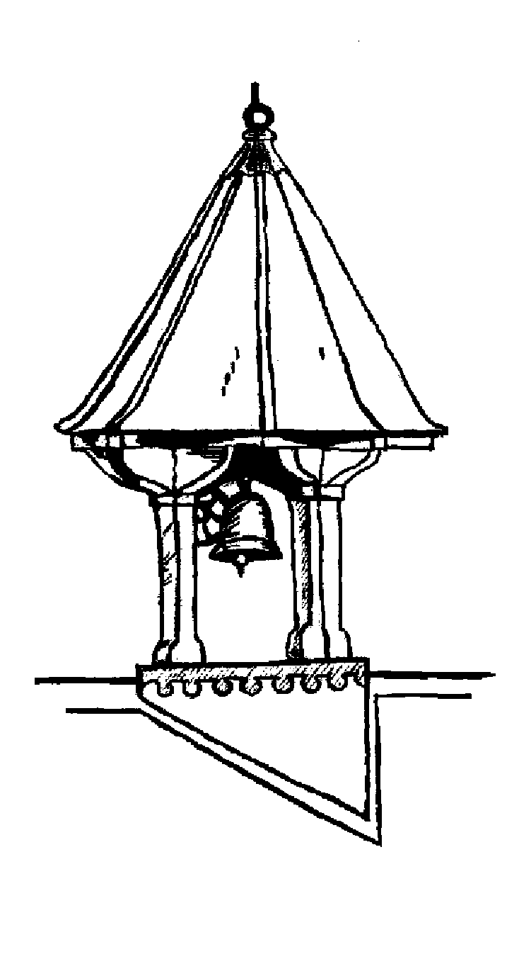
Goring Heath Parish Charity
AUTUMN 2017 SHOW
ENTRY FORM
Please use the form below for your entries.
Number of entries: ___ I enclose fees (30p per entry): ___
Name : _________________ Tel No : ________________
Address : ______________________________________
___________________________ Age of child : ________
All entry forms should be given to a member of the committee from Wednesday 30 August and no later than 4.30pm on Friday 1 September 2017. Late entries only at the discretion of the committee. See overleaf for contact details.
Please circle below the number of each class you are entering.

Section | Class
A | 1 | 2 | 3 | 4 | 5 | 6 | 7 | 8 | 9 | 10 | 11 | 12 | 13 | 14 | 15 | 16
A | 17 | 18 | 19 | 20 | 21 | 22 | 23 | 24 | 25 | 26
B | 27 | 28 | 29 | 30 | 31 | 32 | 33 | 34 | 35 | 36 | 37 | 38 | 39 | 40 | 41 | 42
C | 43 | 44 | 45 | 46
D | 47 | 48 | 49
E | 50 | 51 | 52 | 53 | 54 | 55
F | 56 | 57 | 58
G | 59 | 60 | 61

Please make sure that you read the schedule carefully. For copies of schedule or entry form please go to http://www.whitchurchonthames.com/diary.php or www.goringheath.com

